Journal of Information, Computing and Communication

Author K1* Author K2 Author K3 Author K4 Author K5 Author K6

1*Author Affiliation

2Author Affiliation

3Author Affiliation

*Corresponding author

**Abstract: This article provides a comprehensive overview of the articles published in the Journal of Information Computing and Communication. The abstract should be written in an engaging and motivating manner to encourage readers to explore the entire article. It must be formatted in Times New Roman font, with a font size of 11. Authors are encouraged to use this template when preparing the final version of their manuscripts.**

**Key Words: List of Keywords. All the keywords should be separated with commas. Minimum of five keywords should be entered.**

1. **INTRODUCTION**

The introduction of a research article serves as a foundational component, setting the stage for the study by providing essential background information, identifying the research problem, and outlining the study’s objectives. It begins by introducing the broader context of the topic, summarizing relevant literature, and highlighting any existing gaps in knowledge. The introduction then specifies the research questions or hypotheses the study aims to address, framing the direction of the investigation [1].

1. **RELATED WORK**

The literature survey in a research article provides a comprehensive review of previous studies, theories, and key findings related to the research topic, helping to contextualize the current study. It begins by highlighting the foundational works and major contributions in the field, summarizing relevant theories, models, and methodologies that have been previously explored. The survey identifies key trends, areas of agreement, and any discrepancies or gaps in the literature.

1. **PROPOSED APPROACH**

The proposed approach in the research article outlines the methodology and framework.

* 1. ***Sub section 1***

The sub section of the proposed approach can be written here.

* 1. ***Subsection 2***

The sub section of the proposed approach can be written here. The equations are represented as **eq.1** inside the text.

$x_{i}^{N_new}= {px}_{barnacle_d}^{N} k≤pl$ (1)

$x_{i}^{N_new}= rand()$ (2)

$f\left(x\right)= \frac{1}{\sqrt{2πσ^{2}}}e^{-\frac{{(x-μ)}^{2}}{{2σ}^{2}}}$ (6)

**Table 1. Comparison**

|  |  |  |  |
| --- | --- | --- | --- |
| Dataset-1 | Measure | GA | SVM |
| Accuracy | 0.664 | 0.689 |
| Precision | 0.720 | 0.754 |
| Recall | 0.832 | 0.852 |
| F-score | 0.732 | 0.765 |
| Process time | 1.48s | 1.41s |

The Table represented as **table 1** and be interpreted well in the text of the research article.

**Table 2: Algorithms**

|  |
| --- |
| **Algorithm: Name of the Algorithm** |
| Statement  Statement  Statement  Statement  Statement  Statement  Statement  Statement |

The data collection procedures, and the analytical strategies used to draw conclusions. Furthermore, the proposed approach highlights any innovative methods.

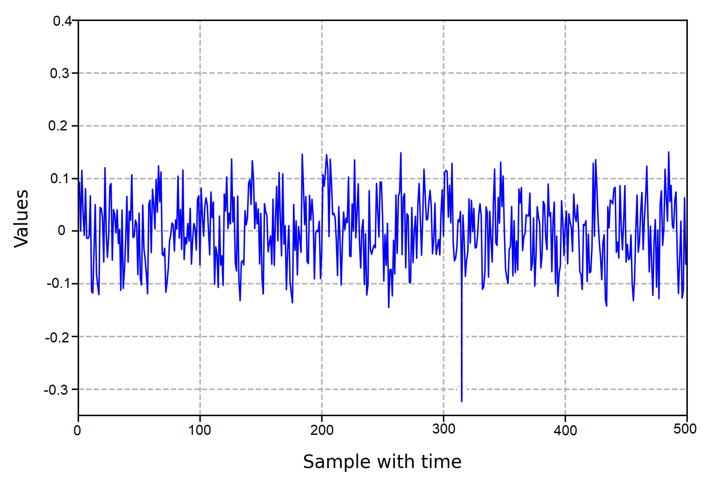

**Figure 1. Subject’s condition**

The figure should be interpreted and cited in the text as **fig.1**.

1. **RESULTS AND DISCUSSIONS**

The "Results and Discussion" section of a research article presents the findings of the study and interprets their meaning in the context of the research questions or hypotheses. The "Results and Discussion" section of a research article presents the findings of the study and interprets their meaning in the context of the research questions or hypotheses.

1. **CONCLUSION**

The **Conclusion** of a research paper succinctly summarizes the main findings and their implications, providing a final perspective on the study. It restates the research problem and highlights how the results address the initial research questions or hypotheses. This section emphasizes the significance of the study's contributions to the field, drawing attention to its practical, theoretical, or policy implications.

**CONFLICT OF INTEREST**

We declare that there are no conflicts of interest related to this research. No financial, personal, or professional relationships have influenced the design, data collection, analysis, or interpretation of the study results. All funding sources and potential conflicts of interest have been fully disclosed, and the authors affirm that this study was conducted independently without external influence.

REFERENCES

1. **Book**: Smith, J. A. (2019). Introduction to psychology (3rd ed.). Academic Press.
2. **Journals**: Doe, J., & Brown, R. L. (2020). Cognitive behavioral therapy in adolescents: A review. Journal of Clinical Psychology, 45(2), 123-135. https://doi.org/10.1002/jclp.22857.
3. **Websites**: Williams, K. (2021, March 15). Understanding mental health in teens. Psychology Today. https://www.psychologytoday.com/teens-mental-health.
4. **Edited Book Chapters**: Martin, A. C. (2018). Stress and coping in adulthood. In L. J. McKinney & H. D. Harris (Eds.), Psychology and aging (pp. 201-220). Springer.
5. **Conference Papers:** Clark, R. P. (2021, June). Exploring new teaching methods in education. In R. T. James & M. L. Green (Eds.), Proceedings of the International Conference on Education (pp. 100-115). Springer.
6. **Reports**: National Institute of Mental Health. (2020). Mental health and adolescent development (Report No. 23-457). U.S. Government Printing Office. https://www.nimh.nih.gov/reports/mental-health-adolescents.